Project Documentation

Project Title: Simple Calculator

**Project Overview:**

The Simple Calculator project aims to create a basic calculator with fundamental arithmetic operations: addition, subtraction, multiplication, and division. The project includes a Calculator class that implements these operations and a corresponding JUnit test class to ensure the correctness of the calculator's functionality.

**Project Structure:**

The project is organized into two main classes:

1. **Calculator Class (org.example.Calculator):**

* Implements basic arithmetic operations: add, subtract, multiply, and divide.
* Handles division by zero by throwing an **“IllegalArgumentException”**.

1. **CalculatorTest Class:**

* JUnit test class to verify the correctness of the Calculator class methods.
* Includes tests for each arithmetic operation and a special case for division by zero.

**Class Details:**

**1. Calculator Class (org.example.Calculator):**

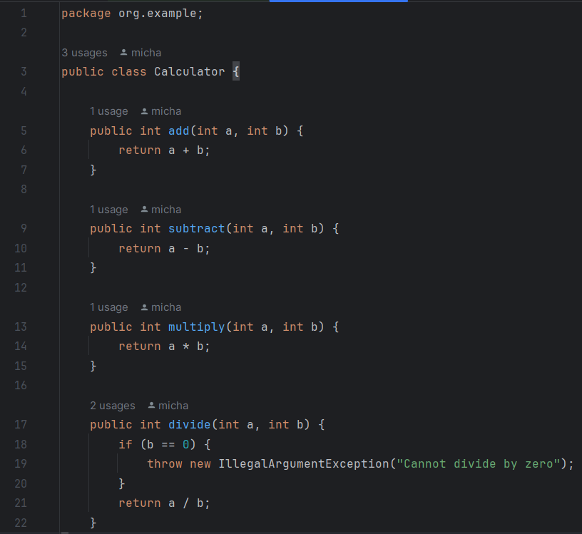

**2. CalculatorTest Class:**

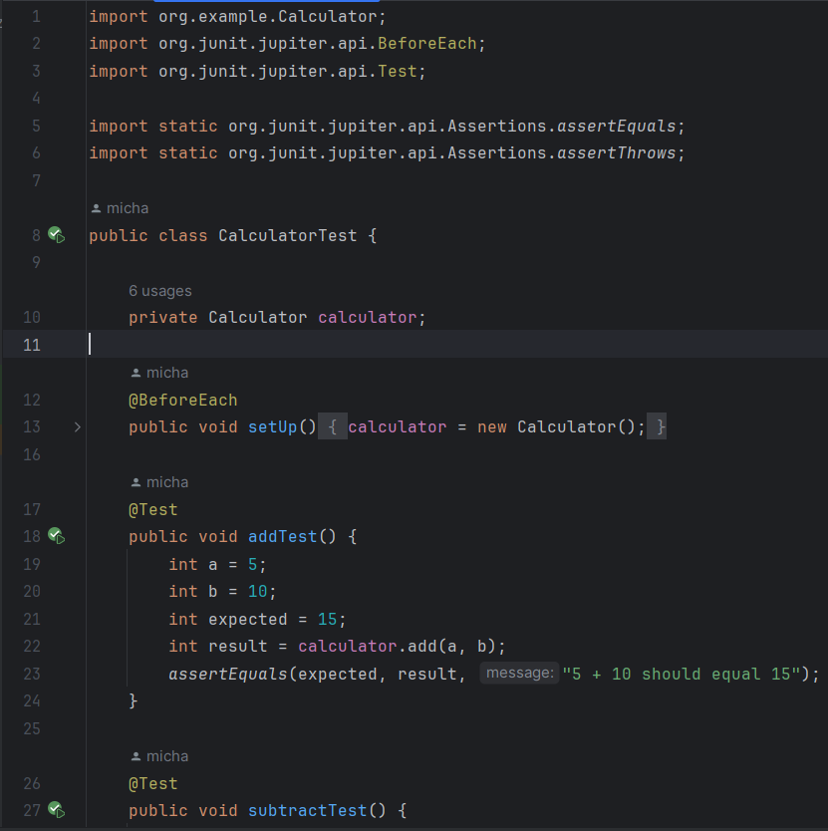

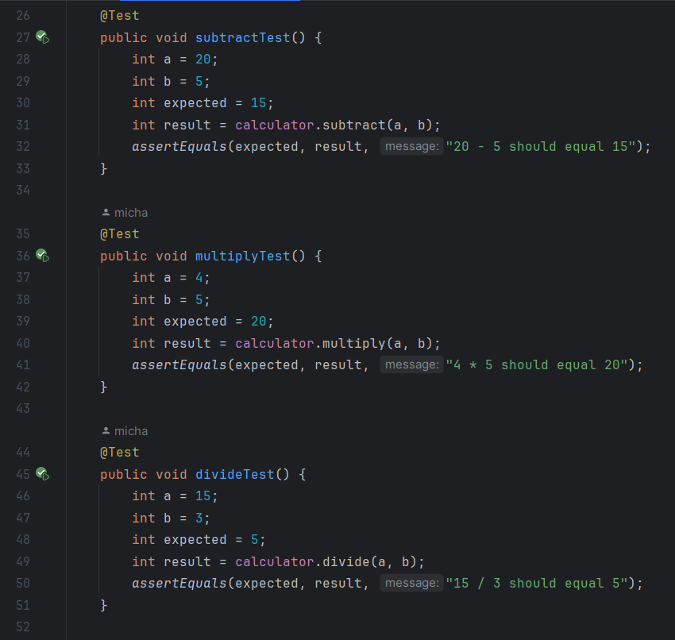

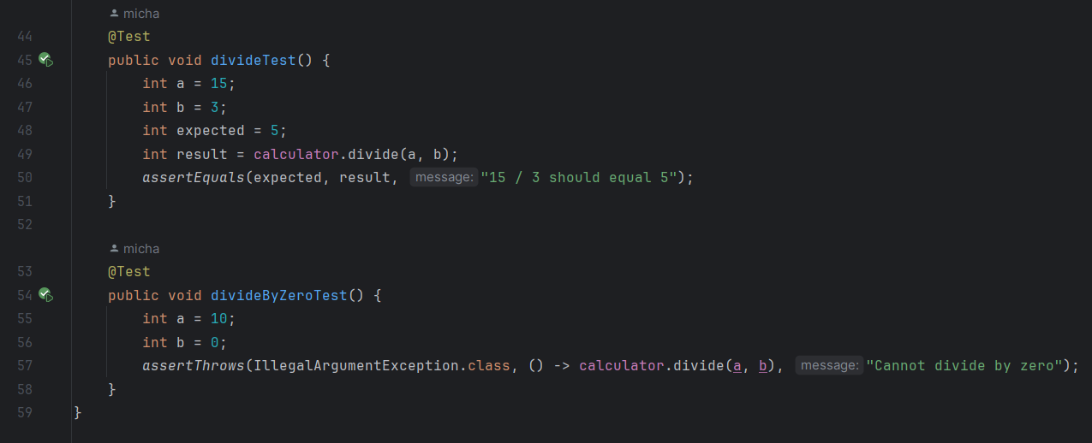

**Conclusion:**

The Simple Calculator project provides a reliable set of basic arithmetic operations implemented in the Calculator class, accompanied by a comprehensive JUnit test suite in the CalculatorTest class to ensure the correctness of the implemented functionality. The project is well-organized, modular, and follows best practices for unit testing in Java.